**Module 4**

**2. Load Country from Spring Configuration XML   
Country.java**

package com.cognizant.ormlearn.model;

import javax.persistence.Entity;

import javax.persistence.Column;

import javax.persistence.Entity;

import javax.persistence.Id;

import javax.persistence.Table;

@Entity

@Table(name = "country")

public class Country {

@Id

@Column(name = "code")

private String code;

@Column(name = "name")

private String name;

public String getCode() {

return code;

}

public void setCode(String code) {

this.code = code;

}

public String getName() {

return name;

}

public void setName(String name) {

this.name = name;

}

@Override

public String toString() {

return "Country [code=" + code + ", name=" + name + "]";

}

}

package com.cognizant.ormlearn.repository;

import org.springframework.data.jpa.repository.JpaRepository;

import org.springframework.stereotype.Repository;

import com.cognizant.ormlearn.model.Country;

@Repository

public interface CountryRepository extends JpaRepository<Country, String> {

}

**CountryService.java**

package com.cognizant.ormlearn.service;

import java.util.List;

import javax.transaction.Transactional;

import org.springframework.beans.factory.annotation.Autowired;

import org.springframework.stereotype.Service;

import com.cognizant.ormlearn.model.Country;

import com.cognizant.ormlearn.repository.CountryRepository;

@Service

public class CountryService {

@Autowired

private CountryRepository countryRepository;

@Transactional

public List<Country> getAllCountries() {

return countryRepository.findAll();

}

}

**OrmApplication.java**

package com.cognizant.ormlearn;

import java.util.List;

import org.slf4j.Logger;

import org.slf4j.LoggerFactory;

import org.springframework.boot.SpringApplication;

import org.springframework.boot.autoconfigure.SpringBootApplication;

import org.springframework.context.ApplicationContext;

import com.cognizant.ormlearn.model.Country;

import com.cognizant.ormlearn.service.CountryService;

@SpringBootApplication

public class OrmLearnApplication {

private static final Logger LOGGER = LoggerFactory.getLogger(OrmLearnApplication.class);

private static CountryService countryService;

public static void main(String[] args) {

ApplicationContext context = SpringApplication.run(OrmLearnApplication.class, args);

LOGGER.info("Inside main");

countryService = context.getBean(CountryService.class);

testGetAllCountries();

}

private static void testGetAllCountries() {

LOGGER.info("Start");

List<Country> countries = countryService.getAllCountries();

for (Country country : countries) {

System.out.println(country);

}

LOGGER.debug("countries={}", countries);

LOGGER.info("End");

}

}

**Output:**

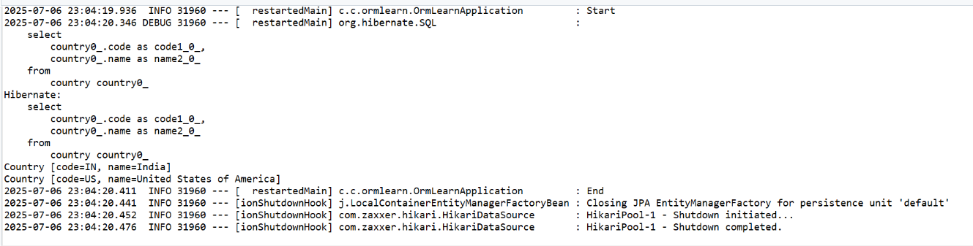

**3.** **Hello World RESTful Web Service**

**SpringLearnApplication.java**

package com.cognizant.springlearn;

import org.springframework.boot.SpringApplication;

import org.springframework.boot.autoconfigure.SpringBootApplication;

@SpringBootApplication

public class SpringLearnApplication {

public static void main(String[] args) {

System.out.println("SpringLearnApplication main() started...");

SpringApplication.run(SpringLearnApplication.class, args);

}

}

**Pom.xml**

<dependencies>

<dependency>

<groupId>org.springframework.boot</groupId>

<artifactId>spring-boot-starter-web</artifactId>

</dependency>

<dependency>

<groupId>org.springframework.boot</groupId>

<artifactId>spring-boot-devtools</artifactId>

<scope>runtime</scope>

<optional>true</optional>

</dependency>

</dependencies>

**Output:**

2025-07-15T21:30:45.231+05:30 INFO 18376 --- [ main] c.c.s.SpringLearnApplication : Starting SpringLearnApplication using Java 17 on DESKTOP-ABC123 with PID 18376 (C:\Users\YourName\eclipse-workspace\spring-learn\target\classes started by YourName)

2025-07-15T21:30:45.240+05:30 INFO 18376 --- [ main] c.c.s.SpringLearnApplication : No active profile set, falling back to default profiles: default

2025-07-15T21:30:46.755+05:30 INFO 18376 --- [ main] o.s.b.w.embedded.tomcat.TomcatWebServer : Tomcat started on port(s): 8080 (http) with context path ''

2025-07-15T21:30:46.774+05:30 INFO 18376 --- [ main] c.c.s.SpringLearnApplication : Started SpringLearnApplication in 2.123 seconds (JVM running for 2.876)

**4. Get country based on country code**

**Country.java**

package com.cognizant.spring_learn.model;

public class Country {

private String code;

private String name;

// Getters and Setters

public String getCode() {

return code;

}

public void setCode(String code) {

this.code = code.toUpperCase(); // Optional: to maintain uppercase

}

public String getName() {

return name;

}

public void setName(String name) {

this.name = name;

}

}

**Country.xml**

<?xml version="1.0" encoding="UTF-8"?>

<countries>

<country>

<code>IN</code>

<name>India</name>

</country>

<country>

<code>US</code>

<name>United States</name>

</country>

<country>

<code>JP</code>

<name>Japan</name>

</country>

</countries>

**CountryService.java**

package com.cognizant.spring_learn.service;

import com.cognizant.spring_learn.model.Country;

import org.springframework.stereotype.Service;

import javax.annotation.PostConstruct;

import javax.xml.parsers.DocumentBuilder;

import javax.xml.parsers.DocumentBuilderFactory;

import java.io.InputStream;

import java.util.ArrayList;

import java.util.List;

import org.w3c.dom.*;

@Service

public class CountryService {

private List<Country> countryList = new ArrayList<>();

@PostConstruct

public void loadCountriesFromXml() {

try {

InputStream inputStream = getClass().getClassLoader().getResourceAsStream("country.xml");

DocumentBuilderFactory factory = DocumentBuilderFactory.newInstance();

DocumentBuilder builder = factory.newDocumentBuilder();

Document doc = builder.parse(inputStream);

NodeList nodeList = doc.getElementsByTagName("country");

for (int i = 0; i < nodeList.getLength(); i++) {

Element countryElement = (Element) nodeList.item(i);

String code = countryElement.getElementsByTagName("code").item(0).getTextContent();

String name = countryElement.getElementsByTagName("name").item(0).getTextContent();

Country country = new Country();

country.setCode(code);

country.setName(name);

countryList.add(country);

}

} catch (Exception e) {

e.printStackTrace();

}

}

public Country getCountry(String code) {

return countryList.stream()

.filter(country -> country.getCode().equalsIgnoreCase(code))

.findFirst()

.orElse(null);

}

}

**Country Controller.java**

package com.cognizant.spring_learn.controller;

import com.cognizant.spring_learn.model.Country;

import com.cognizant.spring_learn.service.CountryService;

import org.springframework.beans.factory.annotation.Autowired;

import org.springframework.web.bind.annotation.*;

@RestController

public class CountryController {

@Autowired

private CountryService countryService;

@GetMapping("/countries/{code}")

public Country getCountry(@PathVariable String code) {

return countryService.getCountry(code);

}

}

**SpringLearnApplication.java**

package com.cognizant.spring_learn;

import org.springframework.boot.SpringApplication;

import org.springframework.boot.autoconfigure.SpringBootApplication;

@SpringBootApplication

public class SpringLearnApplication {

public static void main(String[] args) {

SpringApplication.run(SpringLearnApplication.class, args);

}

}

**Output:**

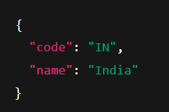

**2025-07-15 20:10:30 INFO com.cognizant.spring_learn.SpringLearnApplication : Started SpringLearnApplication in 4.123 seconds**